NAME: K Yamini
REG NO: 192572181

Write a Prolog Program to suggest Dieting System based on Disease.
Aim:
To implement a simple Prolog-based diet suggestion system that provides example food suggestions based on a given disease.
Algorithm:
- Start the program.
- Define different diseases as facts.
- Define example diet suggestions for each disease.
- Create a rule to connect a disease with its diet.
- Take the disease as a query.
- Prolog searches the database for matching diet information.
- Display the suggested diet.
- Stop the program.
Prolog program:
% EXPERIMENT 24
% Dieting System Based on Disease

% Diet facts
diet(fever, 'Drink plenty of fluids and eat light foods').
diet(cold, 'Eat warm foods and drink plenty of fluids').
diet(diabetes, 'Choose balanced meals with controlled sugar').
diet(anemia, 'Include iron-rich foods and balanced meals').
diet(obesity, 'Choose balanced meals and more fruits and vegetables').

% Rule to suggest diet
suggest_diet(Disease, Diet) :-
diet(Disease, Diet).

% Display diet suggestion
show_diet(Disease) :-
diet(Disease, Diet),
write('Disease: '),
write(Disease),
nl,
write('Suggested Diet: '),
write(Diet),
nl.
Input:
?- show_diet(fever).

Output :
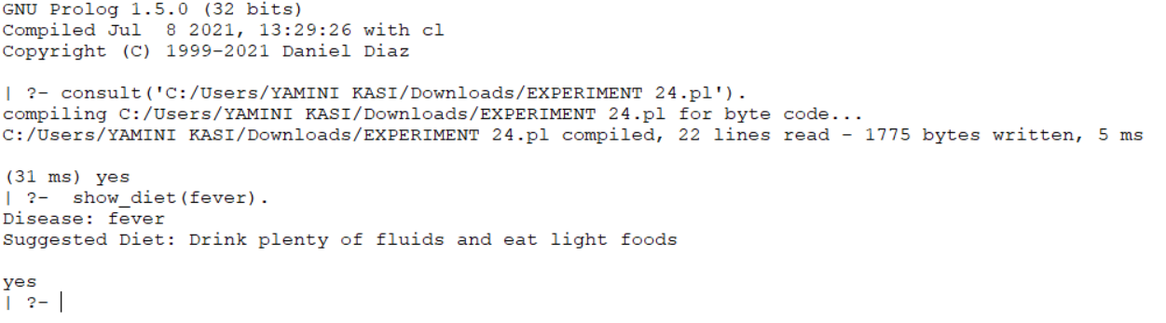
Result:
Thus, the Prolog-based dieting system was successfully implemented using facts and rules to provide example diet suggestions based on a given disease.

